**Employee Information Form**

**(Note: Kindly write all in CAPITAL letters except for email id)**

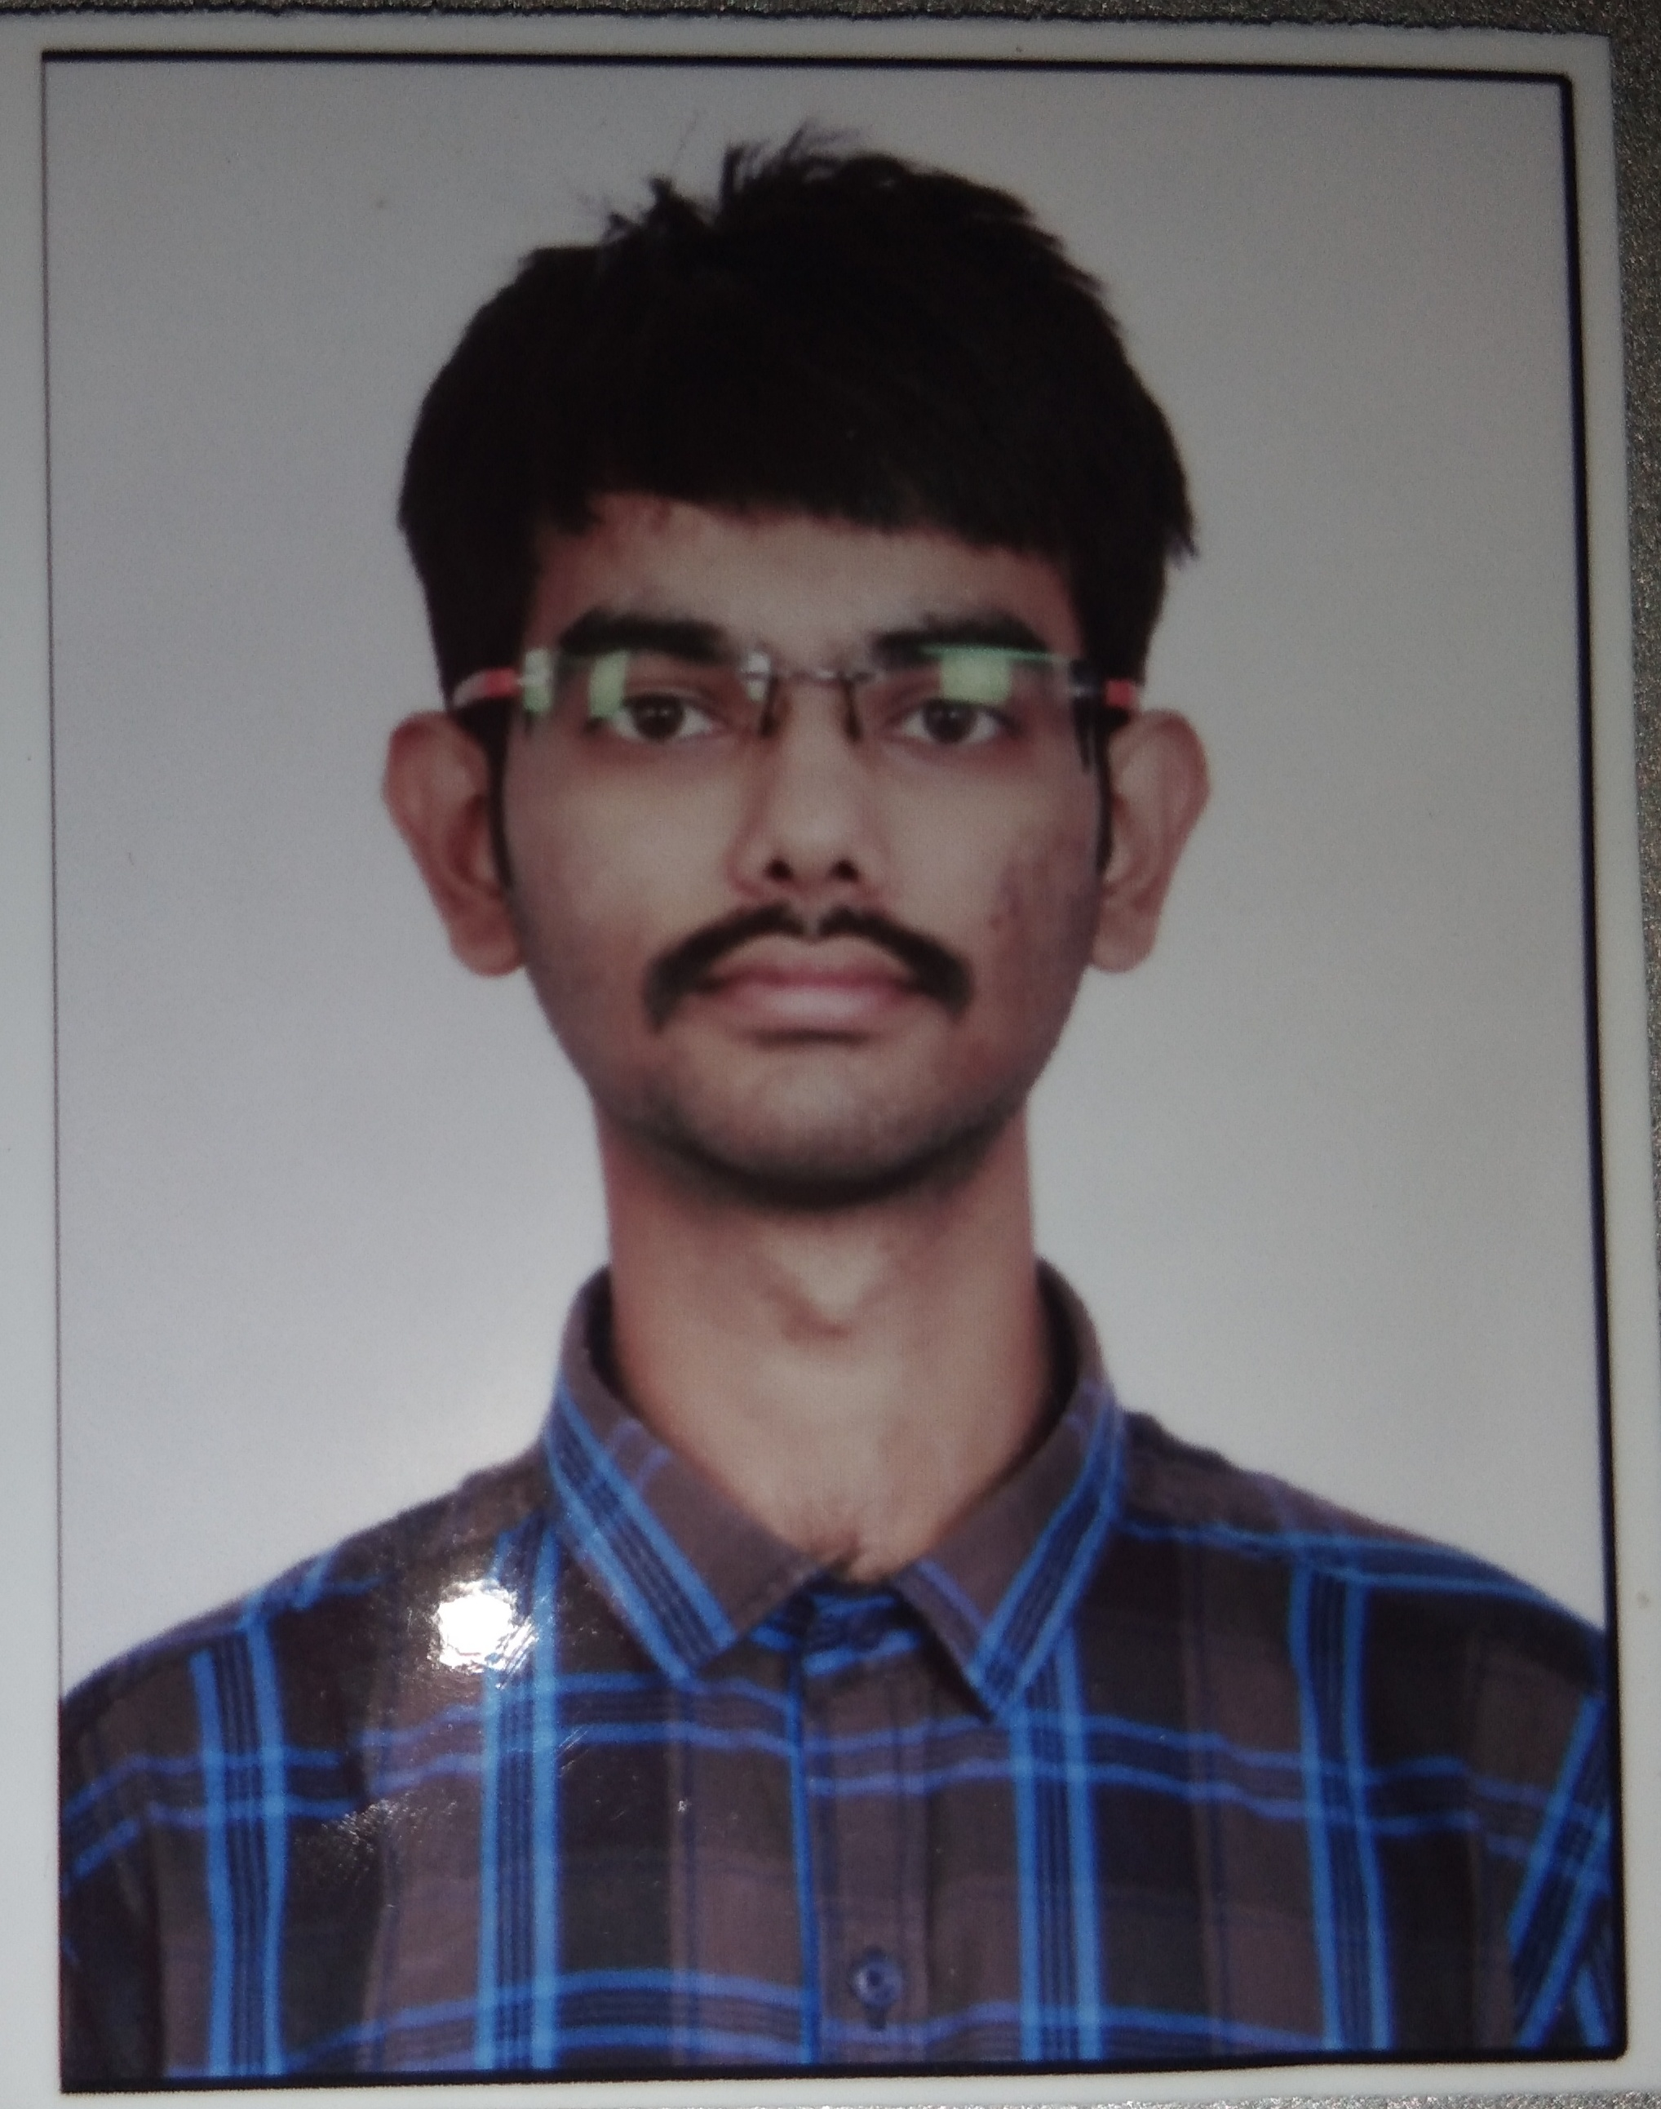**Photograph**

|  |  |
| --- | --- |
| Employee Name (First, Middle, Last) | SHIVAKUMAR R HOMBAL |
| Emp. Id | 5948 |
| Designation | ASSOCIATE SOFTWARE ENGINEER - TRAINEE |
| Personal E-mail Address | hombalshivakumar@gmail.com |
| Dept. / Division | SES- ASSOCIATE SOFTWARE ENGINEER - TRAINEE |
| Date of joining (DD/MM/YYYY) | 23/08/2021 |

## Personal Information:

|  |  |
| --- | --- |
| Father’s Name: | RAMESH HOMBAL |
| Gender (M or F) | M |
| Date of birth (DD/MM/YYYY) | 15/11/1999 |
| Marital status    Spouse Name:  Spouse’ Date of birth  (DD/MM/YYYY | Married Single ✓ |
| Blood group | B+ |
| Current Address (with PIN code)  Contact No | F-187, 1st MAIN ROAD, BHARATH NAGAR, VISHWANEEDAM POST, BANGALORE – 560091,  **+917892616189**  (Country code) (City Code) (Phone No) |
| Permanent Address  (with PIN code)  Contact No | SAME AS ABOVE  (Country code) (City Code) (Phone No) |
| Mobile Number | +917892616189 |

|  |  |
| --- | --- |
| Passport details | No:  Place of issue:  Date of Issue:  Expiry Date: |

|  |  |
| --- | --- |
| Driving licence details | No:  Place of issue:  Date of Issue: Expiry Date: |
| Do you have any relatives in THBS | Yes No ✓ If yes, mention the name: |
| Languages Known | Languages Read Write Speak  1. KANNADA YES YES YES  2. ENGLISH YES YES YES  3. HINDI YES YES YES  4.  5. |

**Emergency Contact Details** (for emergency notification purposes only)

|  |  |
| --- | --- |
| Name | RAMESH HOMBAL |
| Relation | FATHER |
| Address | F-187, 1st MAIN ROAD, BHARATH NAGAR, VISHWANEEDAM POST, |
|  | BANGALORE – 560091, NEAR SBI BANK, EAST WEST COLLEGE ROAD |
|  |
| Contact Number | Work: Home / Mobile: +919900491065 |

**Parents/Spouse Contact Details**

|  |  |
| --- | --- |
| Name | MANJULA R HOMBAL |
| Relation | MOTHER |
| Address | F-187, 1st MAIN ROAD, BHARATH NAGAR, VISHWANEEDAM POST, |
|  | BANGALORE – 560091, NEAR SBI BANK, EAST WEST COLLEGE ROAD |
|  |
| Contact Number | Work: Home / Mobile: +919740193382 |

**Local Friends/Relatives/Guardian Contact Details**

|  |  |
| --- | --- |
| Name | YOGISH H G |
| Relation | FRIEND |
| Address | #307, 9th CROSS, EAST WEST COLLEGE ROAD, BHARATH NAGAR,  1st PHASE |
|  | VISHWANEEDAM POST, BANGALORE - 560091 |
|  |
| Contact Number | Work: Home / Mobile: +919632207800 |

## Qualification details:

|  |  |  |  |  |  |
| --- | --- | --- | --- | --- | --- |
| Qualification | College / Institute Name | Year of Passing | Subject of Specialization | % and Grade Secured | Remarks  (University) |
| X | NEW PUBLIC ENGLISH  SCHOOL | 2015 | S.S.L.C | 83.20 |  |
| XII | SRI CHAITANYA PU COLLEGE | 2017 | SCIENCE | 74 |  |
| Diploma |  |  |  |  |  |
| Graduation | EAST WEST INSTITUTE OF TECHNOLOGY | 2021 | COMPUTER SCIENCE AND ENGINEERING | 7.65 CGPA | YET TO GET 6th, 7th and 8th SEM CERTIFICATR |
| Post  Graduation |  |  |  |  |  |

**Professional Experience:**

Total Relevant Experience (Months): 0

# To,

The HR Department

## Torry Harris Business Solutions

Bangalore

This is state that I will be submitting the following documents by the below mentioned dates:

|  |  |  |
| --- | --- | --- |
| **Documents for submitting** | **Submission dates** | **Reason for delay** |
| Relieving letter from previous employer |  |  |
| Experience letter from the previous employer |  |  |
| Copies of Educational Certificates   1. X 2. XII 3. Diploma 4. Graduation 5. Semester wise marks cards | 21/08/2021  21/08/2021  30/09/2021  21/08/2021 | THE MARKS CARDS ARE YET TO BE GENERATED BY THE VTU BOARD. |
| Last Salary Slip / Proof of Last Salary Drawn |  |  |
| Copy of passport |  |  |

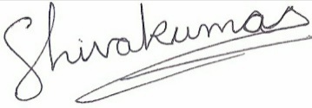

Signature of the employee: Date: 23/08/2021

**E-MAIL ACCOUNT CREATION FORM**

|  |  |  |
| --- | --- | --- |
| **Employee Name** | SHIVAKUMAR R HOMBAL |  |
| **E-mail account ID** | shivakumar_hombal@thbs.com | **Example:**  ***First name Last name***  [*First name_last name@thbs.com*](mailto:Firstname_lastname@thbs.com) |
| **Date submitted (DD/MM/YYYY)** | 23/08/2021 |  |
| **Employee ID** | 5948 |  |
| This is to state that I will utilize the e-mail id only for official purpose and will not misuse it.  **Signature of employee:** | | |

|  |  |  |
| --- | --- | --- |
| **Approval (HR Manager)** | | |
| **Date** |  |  |
| **Name** | Shivdayal Charan |  |
| **Remarks** |  |  |
|  |  | **Signature:** |

|  |  |  |
| --- | --- | --- |
| **Approval (IT)** | | |
| **Date** |  |  |
| **Name** |  |  |
| **Remarks** |  |  |
|  |  | **Signature:** |

|  |  |  |
| --- | --- | --- |
| **System Administrator** | | |
| **Created** |  |  |
| **Date Created** |  |  |
| **Informed to the requester** |  |  |
|  |  | **Signature:** |